**Azure Monitor**

**Azure Monitor** is a full-stack monitoring service that collects, analyzes, and acts on telemetry data from Azure resources and applications. It helps ensure availability, performance, and proactive issue detection.

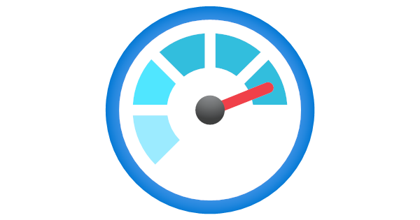

**Features :**

1. **Metrics & Logs Collection** – Gathers real-time performance metrics and activity logs from Azure and custom sources.
2. **Application Insights** – Monitors application performance, user behavior, and exceptions for web apps and services.
3. **Alerts & Notifications** – Automatically triggers alerts and actions based on predefined thresholds or anomalies.
4. **Dashboard & Visualization** – Customizable dashboards for real-time data visualization and analysis.
5. **Integration with Azure Services** – Seamlessly integrates with Logic Apps, Azure Automation, ServiceNow, and more.